TEMPO 4 Population Guide

UVa INERTIA Group 2013

# Bill of Materials

|  |  |  |  |  |  |
| --- | --- | --- | --- | --- | --- |
| **Reference** | **Part Name** | **Qty** | **DigiKey Part #** | **Part Number** | **Description** |
| U4 | AP7312 | 1 | [AP7312-1218W6-7DITR-ND](http://www.digikey.com/product-detail/en/AP7312-1218W6-7/AP7312-1218W6-7DICT-ND/2594052) | AP7312 | Dual Channel 3.3V 150mA LDO |
| C9-10 C13-14 C16 | CAP0603, 100nF | 5 | [445-1316-1-ND](http://www.digikey.com/product-detail/en/C1608X7R1E104K080AA/445-1316-1-ND/567697) | C1608X7R1E104K080AA | MILSPEC 603 CAPACITOR |
| C1 C7-8 | CAP0603, 10uF | 3 | [445-4112-1-ND](http://www.digikey.com/product-detail/en/C1608X5R0J106M080AB/445-4112-1-ND/1975462) | C1608X5R0J106M080AB | MILSPEC 603 CAPACITOR |
| C2-5 C12 | CAP0603, 1uF | 5 | [1276-1041-1-ND](http://www.digikey.com/product-detail/en/CL10F105ZP8NNNC/1276-1041-1-ND/3889127) | CL10F105ZP8NNNC | MILSPEC 603 Capacitor |
| C15 | CAP0603, 2.2nF | 1 | [1276-1110-1-ND](http://www.digikey.com/product-detail/en/CL10B222KB8NNNC/1276-1110-1-ND/3889196) | CL10B222KB8NNNC | MILSPEC 603 CAPACITOR |
| C11 | CAP0603, 4.7uF | 1 | [587-1785-1-ND](http://www.digikey.com/product-detail/en/JMK107BJ475KA-T/587-1785-1-ND/1212801) | JMK107BJ475KA-T | MILSPEC 603 CAPACITOR |
| C6 | CAP0603, 470nF | 1 | [587-1259-1-ND](http://www.digikey.com/product-detail/en/TMK107F474ZA-T/587-1259-1-ND/931036) | TMK107F474ZA-T | MILSPEC 603 CAPACITOR |
| J1 | CON-USB, 5PMINI | 1 | [732-3154-1-ND](http://www.digikey.com/product-detail/en/651305142821/732-3154-1-ND/2627307) | 651305142821 | 5 pin Mini USB type AB connector |
| X1 | CRYSTAL, 32.768kHz | 1 | [300-8301-ND](http://www.digikey.com/product-search/en?vendor=0&keywords=300-8301-ND) | CFS206-32.768KDZB-UB | XTAL 32.768kHz 6pF |
| U2 | FT232RQ | 1 | [768-1008-1-ND](http://www.digikey.com/product-detail/en/FT232RQ-REEL/768-1008-1-ND/1836403) | FT232RQ | USB to RS232 Converter IC |
| D1 | LED Green | 1 | [160-1828-1-ND](http://www.digikey.com/product-detail/en/LTST-C193KGKT-5A/160-1828-1-ND/2356247) | LTST-C193KGKT-5A | MILSPEC 603 LED |
| D2 | LED Red | 1 | [160-1830-1-ND](http://www.digikey.com/product-detail/en/LTST-C193KRKT-5A/160-1830-1-ND/2356251) | LTST-C193KRKT-5A | MILSPEC 603 LED |
| U3 | MAX1555EZK-T | 1 | [MAX1555EZK+TCT-ND](http://www.digikey.com/product-detail/en/MAX1555EZK%2BT/MAX1555EZK%2BTCT-ND/2699449) | MAX1555EZK+T | LiPo Battery Charger IC |
| J3 | MICROSD, PUSH-PUSH | 1 | [HR1964CT-ND](http://www.digikey.com/product-detail/en/DM3AT-SF-PEJM5/HR1964CT-ND/2533566) | DM3AT-SF-PEJM5 | CONN MICRO SD R/A PUSH-PUSH SMD |
| U6 | MPU6050 | 1 | N/A | MPU6050 | 6-Axis I2C Interfaced IMU |
| U1 | MSP430F5342 | 1 | [296-29957-1-ND](http://www.digikey.com/product-detail/en/MSP430F5342IRGZT/296-29957-1-ND/2786087) | MSP430F5342 | 5xxx Series MSP430 Microcontroller |
| M1 | NDS332P | 1 | [NDS332PCT-ND](http://www.digikey.com/product-detail/en/NDS332P/NDS332PCT-ND/428171) | NDS332P | SOT-23 P-CH MOSFET |
| R6-7 | RES0603, 10k | 2 | [P10KGCT-ND](http://www.digikey.com/product-detail/en/ERJ-3GEYJ103V/P10KGCT-ND/134717) | ERJ-3GEYJ103V | MILSPEC 603 RESISTOR |
| R1 R3 R8 | RES0603, 100k | 3 | [P100KGCT-ND](http://www.digikey.com/product-detail/en/ERJ-3GEYJ104V/P100KGCT-ND/134878) | ERJ-3GEYJ104V | MILSPEC 603 RESISTOR |
| R5 | RES0603, 1M | 1 | P1.0MGCT-ND | ERJ-3GEYJ103V | MILSPEC 603 RESISTOR |
| R2 R4 | RES0603, 330 | 2 | [P330GCT-ND](http://www.digikey.com/product-detail/en/ERJ-3GEYJ331V/P330GCT-ND/134778) | ERJ-3GEYJ331V | MILSPEC 603 RESISTOR |
| SW1-2 | SW_PUSHBUTTON | 2 | [P13597SCT-ND](http://www.digikey.com/product-detail/en/EVQ-PNF04M/P13597SCT-ND/1245518) | EVQ-PNF04M | Mom. Pushbutton |

# Board Top Layout and Pin 1 Locations

This image is intended to provide a top-level road map for component location and polarity. All passives have their silkscreen documentation included and ICs have their pin1 locations indicated with a red dot.

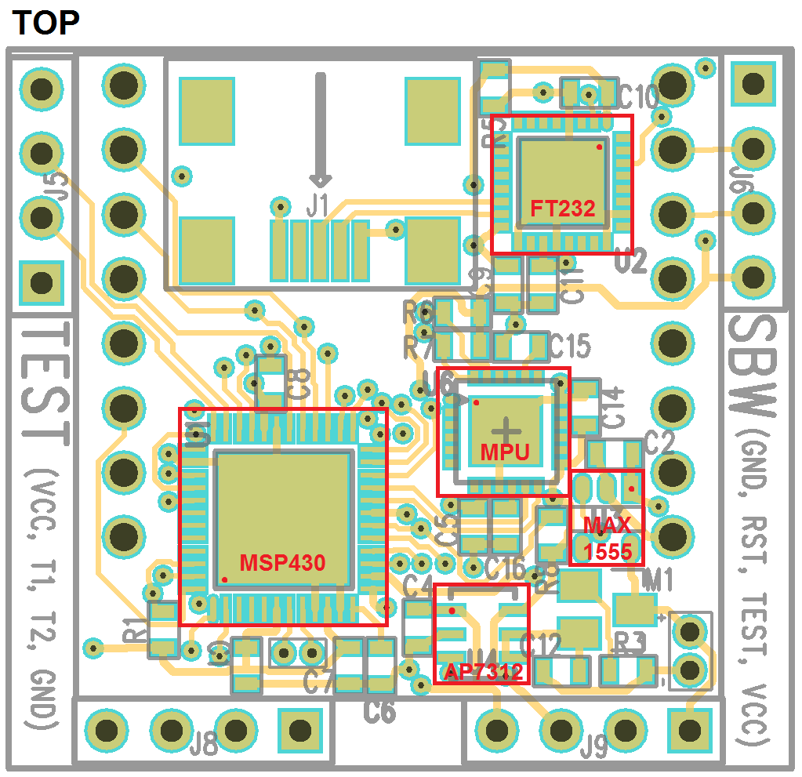

# Board Bottom Layout and Diode Polarity

This image is intended to provide a top-level roadmap for component location and polarity. All passives have their silkscreen documentation included and LEDs have their polarity indicated with an arrow (anode to cathode)

File:Diode symbol.svg

See LED Polarity Reference Based on Die Placement for more information on LED polarity

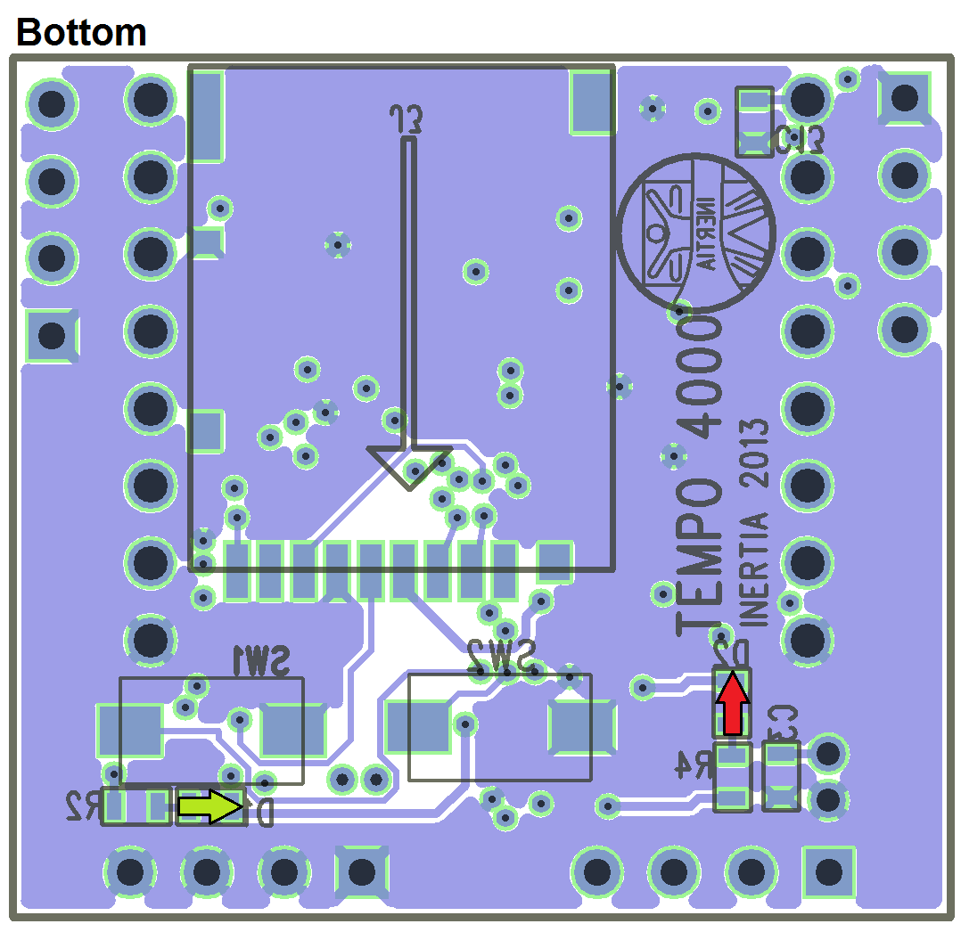

# LED Polarity Reference Based on Die Placement (seen from the top)

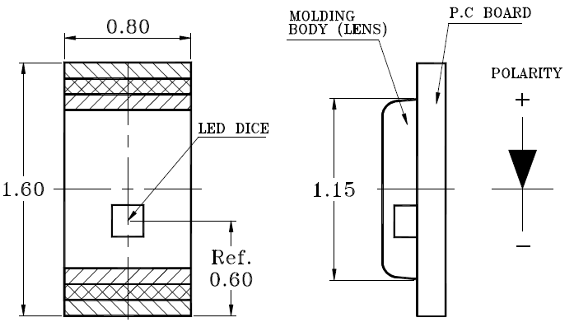

# Questions/Comments/Concerns

Please email any questions, comments, or concerns to Ben Boudaoud ([bb3jd@virignia.edu](mailto:bb3jd@virignia.edu)) or call any time of day at 540-419-0219.

In addition I am more than happy to correct any issues/validate population by hand, on-site provided I am given ample notice of when the job will be done.